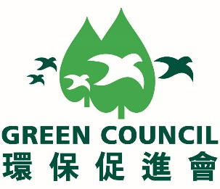

To: Hong Kong Green Day Secretariat Office
Room 703, New World Tower 1,
18 Queen's Road Central,
Hong Kong
Attention: Mr. Jason Yip / Ms Sendy Chan
Fax: +852 2810 1998
Email: hkgreenday@greencouncil.org

REPLY SLIP

Green Council – Hong Kong Green Day
Supporting Organisation Invitation

We are pleased to confirm that our Institute □ will / □ will not accept your invitation to join as a supporting organisation of the captioned event.
( where appropriate)

Name of Organisation:
Contact Person: |  | Contact Tel:
Fax no.: |  | Email address:
Signature and chop: |  | Date:

Remarks: Please email your Organisation’s logo in AI format to hkgreenday@greencouncil.org by 26 February 2018.

If you have any questions, please do not hesitate to contact Mr Jason Yip, +852 2810 1122 (hkgreenday@greencouncil.org).

